Flag of Guyana

The flag of Guyana contains the colour yellow.
We see yellow as a mixture of green light and red light.

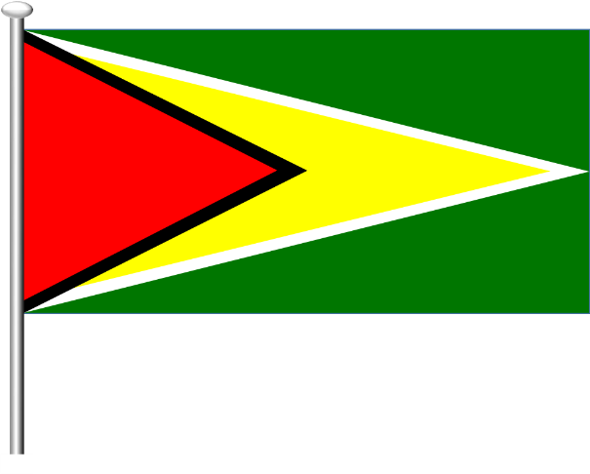
The flag of Guyana shown here is in white light.

Which of these statements about the ‘golden arrow’ are true?
For each statement, tick (✓) one column to show what you think.
Descriptions of the new colour |  | I am sure this is right | I think this is right | I think this is wrong | I am sure this is wrong
A | It reflects red light
B | It absorbs blue light
C | It absorbs green light

Physics > Big idea PSL: Sound, light and waves > Topic PSL2: How we see > Key concept PSL2.2: Seeing in colour
Diagnostic question
Flag of Guyana

Overview
Learning focus: | Light has colours that are seen when reflected by bodies.
Observable learning outcome: | Work out the colour of an object that is a secondary colour, in red, green or blue light.
Question type: | Confidence grid
Key words: | White light, reflect

B | BRIDGING  This diagnostic question probes understanding of ideas that are usually taught at age 14-16, to build a bridge to later stages of learning.

What does the research say?
Martinez-Borreguero et al. (2013) found that students’ explanations of colour formation were most often of the form: ‘bodies have colours that are seen when they reflect light’. They reformulated this explanation to: ‘light has colours that are seen when it is reflected by bodies’ and asked students to consider which statement they found most useful. They found that a shift in focus to the latter made the origin of misunderstandings more explicit and resulted in a significant improvement in students’ longer term conceptual change.
This question investigates how effectively students can apply their understanding of colour formation to a novel situation in which the coloured object reflects more than one colour from the white light. This understanding is necessary in order to explain colour formation when non-primary colours are involved.
Ways to use this question
Students should complete the confidence grid individually. This could be a pencil and paper exercise, or you could use an electronic ‘voting system’ or mini white boards and the PowerPoint presentation.
If there is a range of answers, you may choose to respond through structured class discussion. Ask one student to explain why they gave the answer they did; ask another student to explain why they agree with them; ask another to explain why they disagree, and so on. This sort of discussion gives students the opportunity to explore their thinking and for you to really understand their learning needs.
Differentiation
You may choose to read the questions to the class, so that everyone can focus on the science. In some situations it may be more appropriate for a teaching assistant to read for one or two students.

Expected answers
A and B are correct, C is wrong.
The ‘golden arrow’ reflects red and green light and absorbs blue. The eye combines the reflected red and green light to make yellow.
How to respond - what next?
If students have misunderstandings about how some coloured objects can reflect more than one colour of light, it may help to remind students that white objects reflect all the colours of the spectrum and to demonstrate to them how green and red light combine to make yellow. Students can consolidate their understanding by writing a description or drawing a labelled picture to illustrate how this works. Working in pairs or small groups can encourage social construction of new ideas through dialogue.
The following BEST ‘response activity’ could also be used in follow-up to this diagnostic question:
- Response activity: Flag colours
Acknowledgments
Developed by Peter Fairhurst (UYSEG).
Images: Peter Fairhurst (UYSEG).
References
Martinez-Borreguero, G., et al. (2013). Detection of Misconceptions about Colour and an Experimentally Tested Proposal to Combat them. International Journal of Science Education, 35:8, 1299-1324.

